**Announcement of Our new Logo**

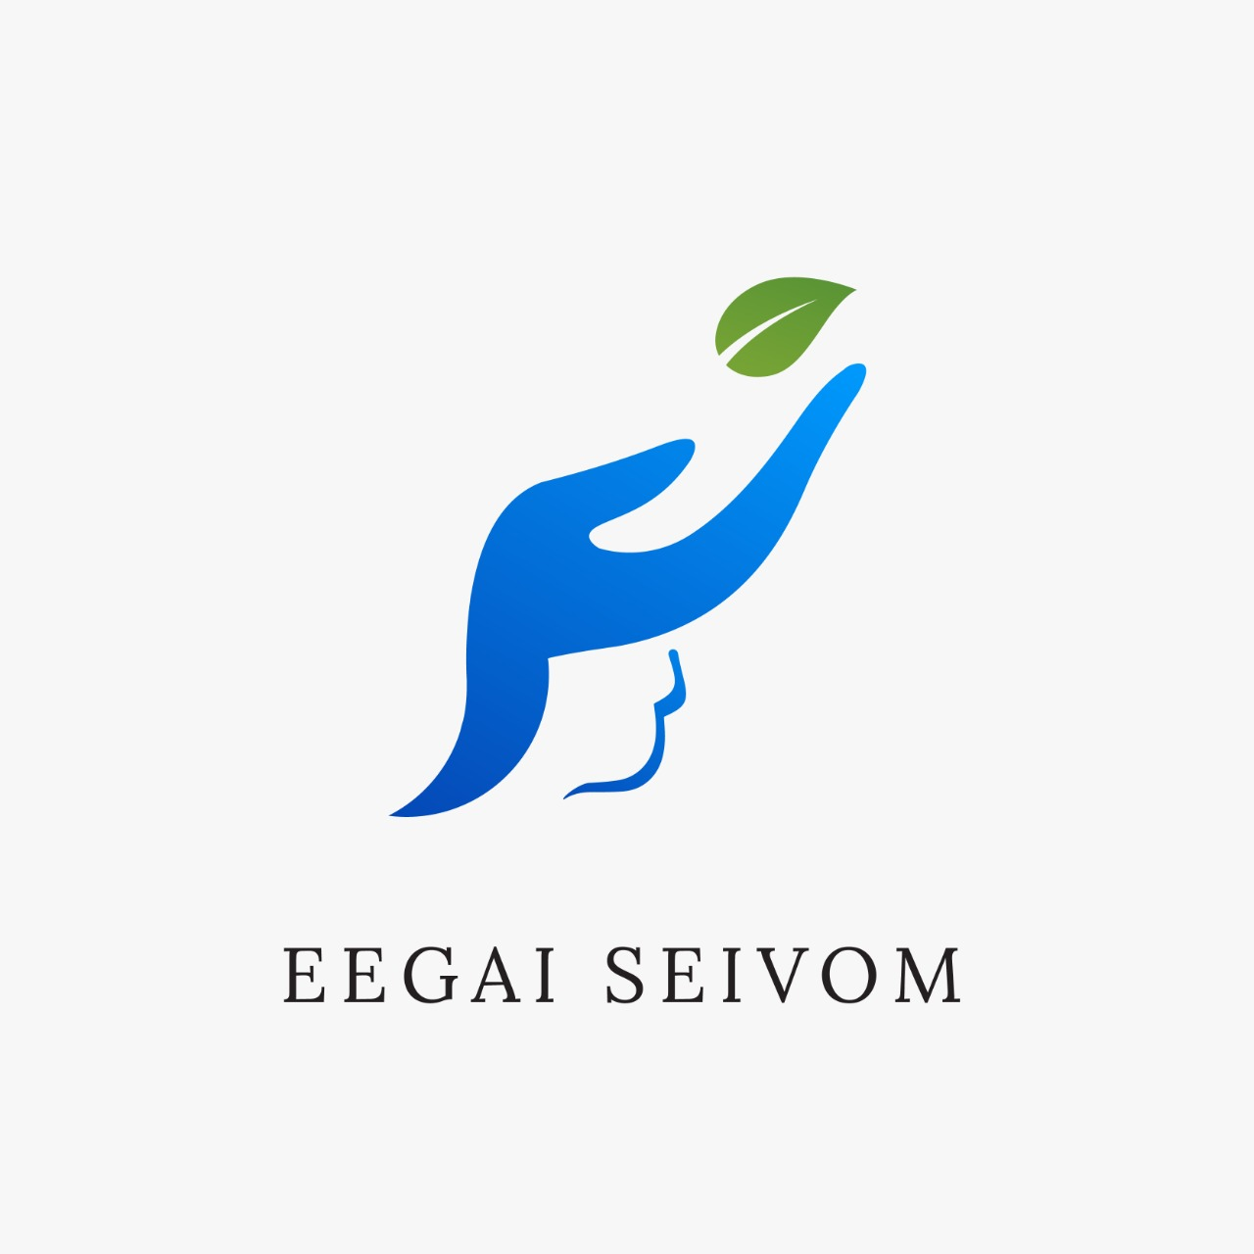

Introducing EEGAI SEIVOM Logo

We are proud to announce the launch of the logo as part of the on-going evolution of our organisation.

We have created our logo to reflect who we are today and to symbolise our future.

After careful consideration, we chose a logo that reflects a more modern look and captures our mission to help people in need.

Where ‘Leaves’ stands for “New Beginning”. The hand symbolize letter ‘e’ starting letter of our organisation. The symbol below the hand represents ‘mother’s womb’ which stands for we are united to care like a mother to our society as a whole, the design swaps the complicated looking structure with a gradient of green-blue colours and more minimalist look. The use of colour ‘blue’ indicates responsibility and trust. The use of colour ‘green’ indicates freshness and new beginning.

With this, we aim to present ourselves better and cater people in need with better services in times to come.

**President Vice President General Secretary** Harish Babu Sri Nivedha Akshaya